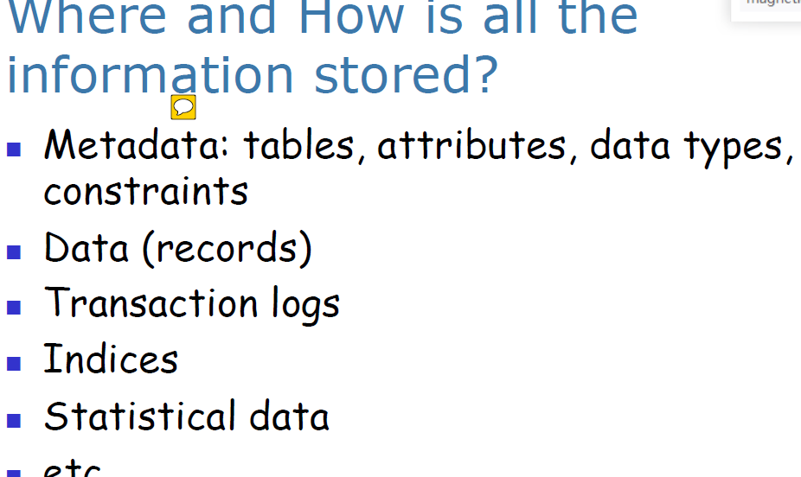

元数据表：收集不同的data，例如attributes, data type, constraints

Data(records): extra records, this is extra data for database, this kind of data also stored on disks

Transaction logs, use transaction logs to recover for different kinds of database fails

Indices, it important for database management ****

Statistical data, we have many statistical data such as, how large is a block

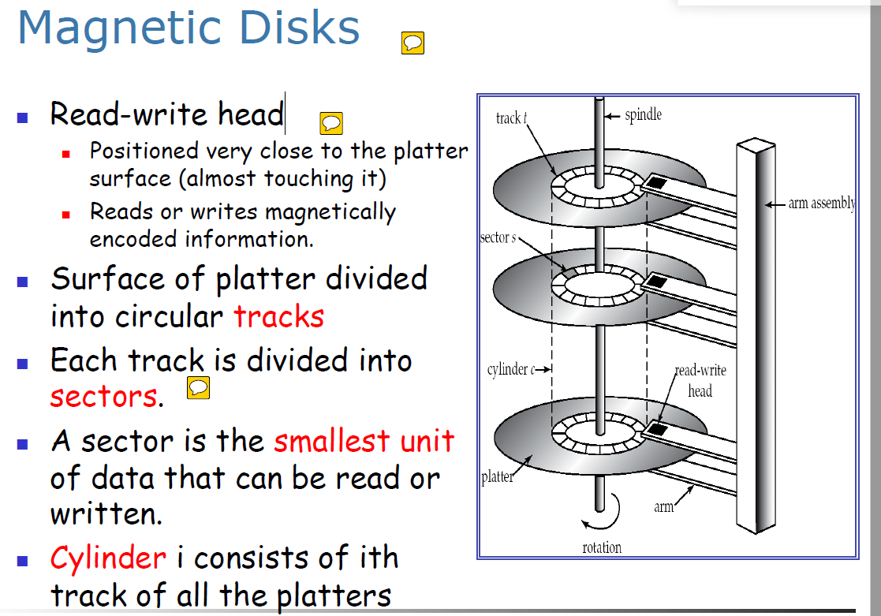

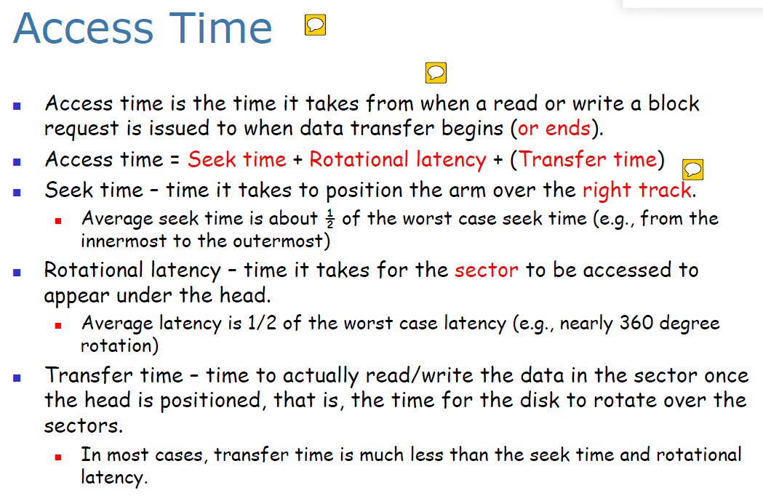

General 来说access time 由=seek time + rotational latency + (transfer time)组成

平均seek time = 1/2（最坏情况下的seek时间）。最坏情况指的是从磁盘的最里面一直搜到

最外才搜到

rotational latency: 就是在正确的磁道上找正确的扇区所花费的时间，最坏情况是1/2(绕了360度才找到正确的sector)。 在大多数情况下transfer time 比起seek time 和 rotational time 要少的多

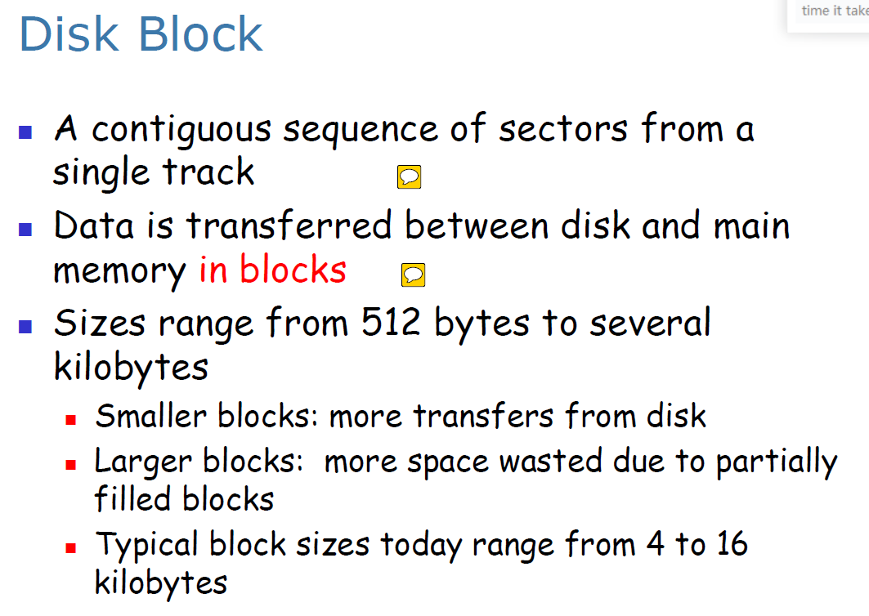

单个磁道中的连续扇区，data usually transfer into block not sectors

Block is the unit of database

Database deal with records which are usually much smaller than a block (although in some cases records may have attributes that are very large).

For a CPU to access data, it must be in main memory, however persistent data(持续数据) must be resident on non-volatile storage such as magnetic disks or SSD.

# Week2

Index：

Order index and